
The University of Azad Jammu & Kashmir
Name | Rizwan Ali
Roll No | 2025-SET-40
Lab No | 02
Instructor | Sir Fahad Nisar
Course | Software Configuration and Management Technologies

1.Directory & Navigation
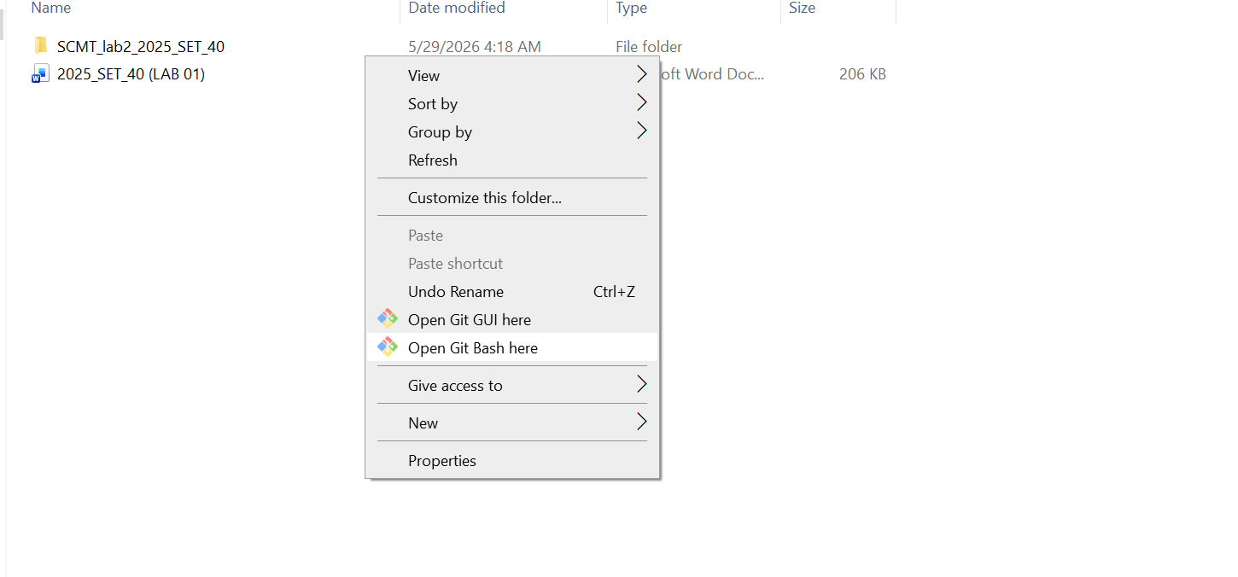

2.Git Repository Initialization

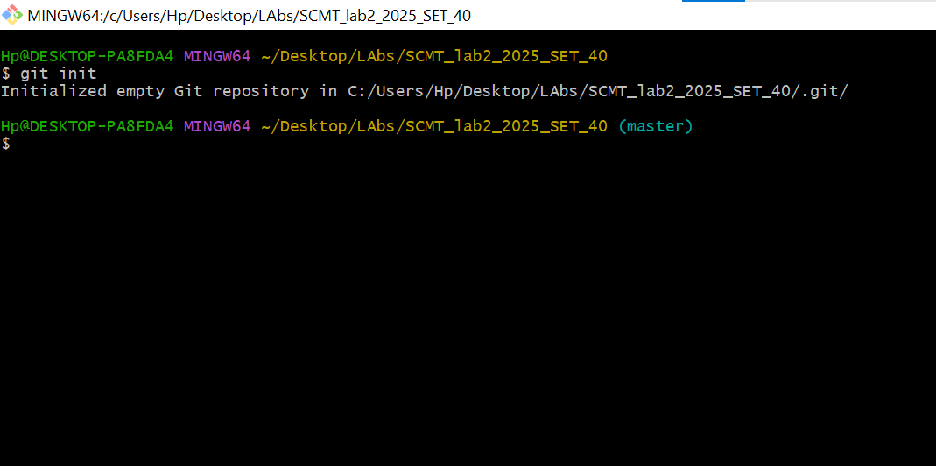

3.Initial git Status

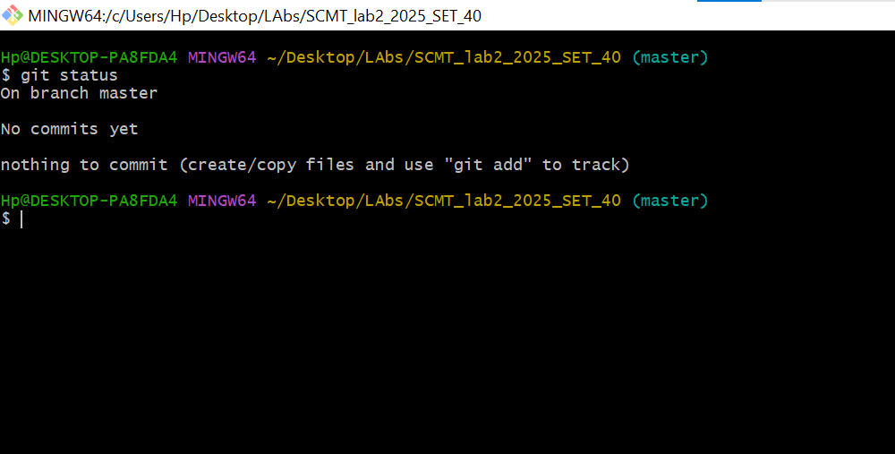

4.Creating & Staging READM.md

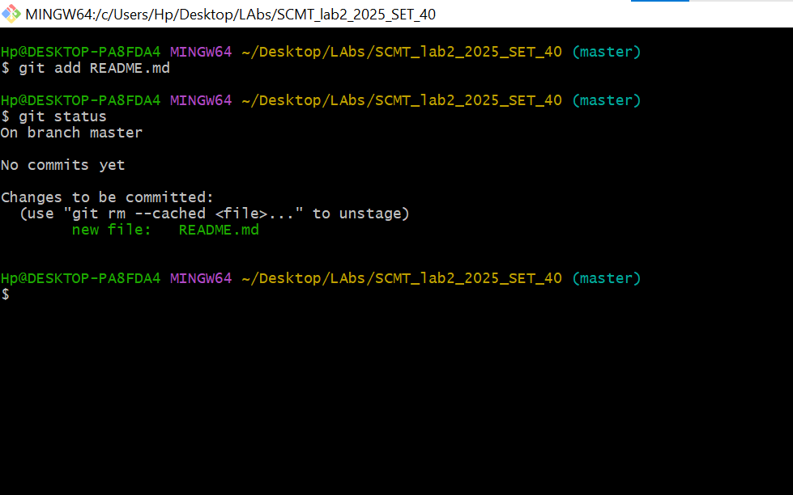
5.First Commit (Initial)
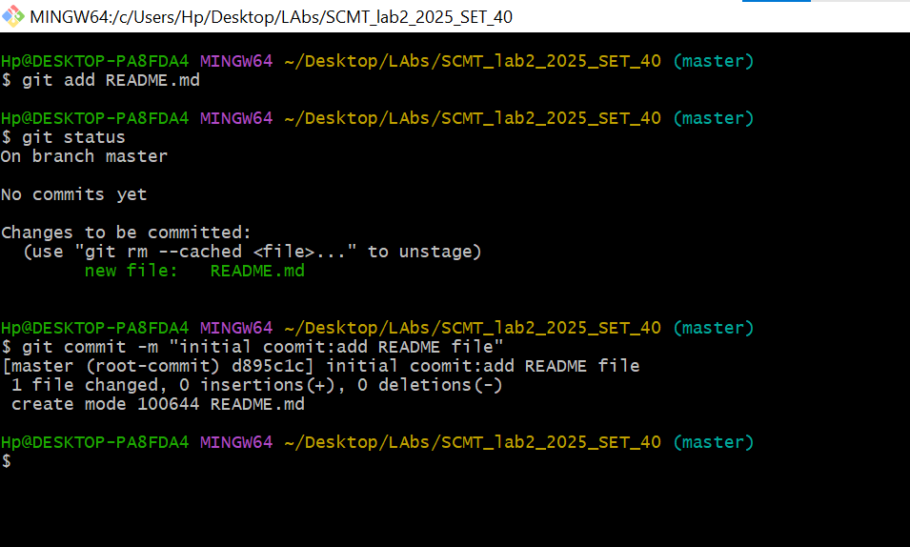
6.Modifying README.md & Second commit

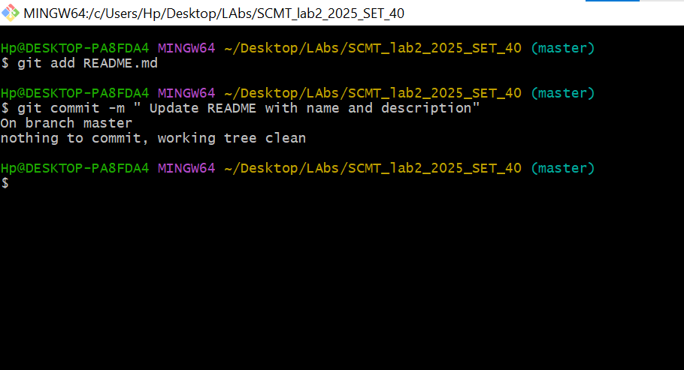

7.Creating Second File & Third Commit

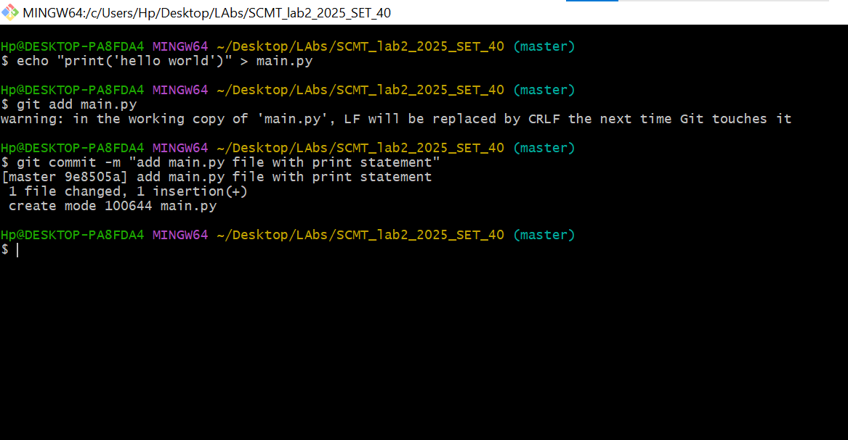

8. Verification Of Working Tree & clean state

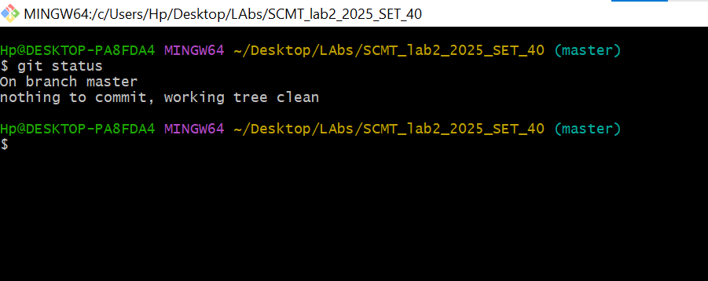

9. Git Log History ( git log --oneline)
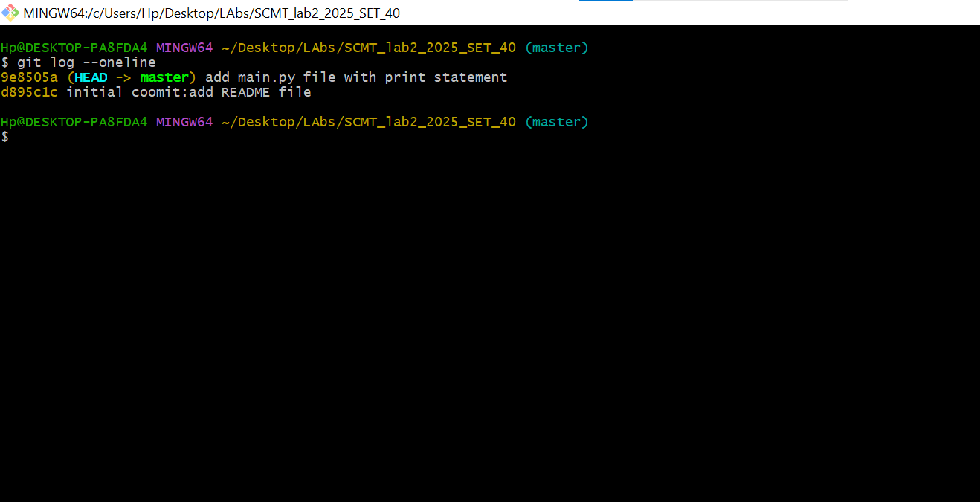

10. Extend Commit Statistics (git log --sat)

